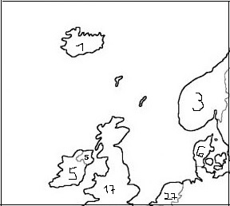

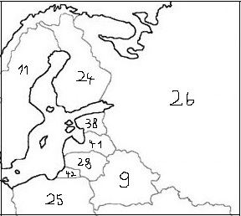

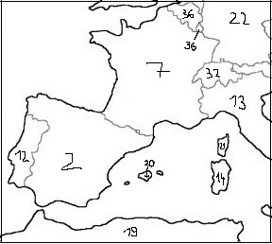

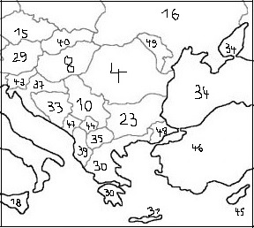

Länder Kinder

1 – 4 Lennard, Selma
5 – 8 Jurij, Kalle
9 – 12 Emila, Mateo
13 – 16 Luce, Clea
17 – 20 Mavie, Anna-Sophia
21 – 24 Joshua, Raphael
25 – 28 Selma A., Moritz
29 – 32 Christina, Alizée
33 – 36 Jerome, Jona
37 – 41 Lenya, Lasse
42 – 46 Rasmus, Selma T.

